3G150M-How to setup the router in Wireless AP Mode?
Product line: 3G Question category: Function configurations

Q: When do we need to choose Wireless AP mode for 3G150M?
A: Sometimes we only have one wired router, but we want to access the Internet wirelessly, then the Wireless AP mode can help you to achieve it.
The topology is as follows：
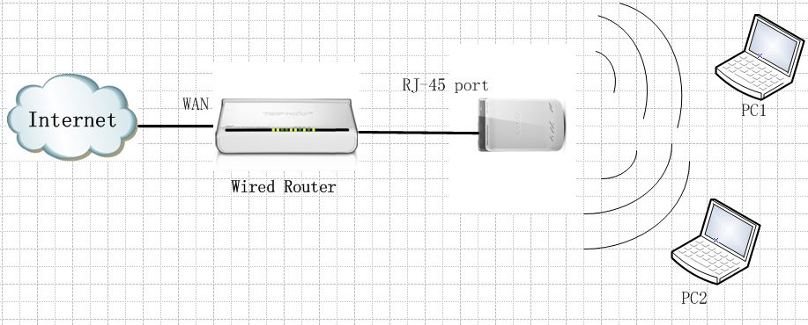
Steps are as below:
1. Connect your computer to the RJ-45 port of the router, then login to the management page of the router through typing http://192.168.0.1 in the address bar of your web browser. Then a pop-up will appear and require to you input username and password, both of them default are admin.
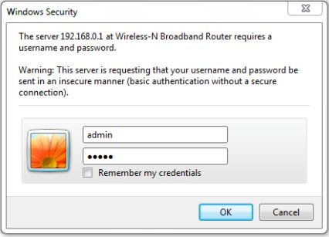
Then you are in the homepage of the router.
2. Please choose Wireless AP among the four modes, and click Next.
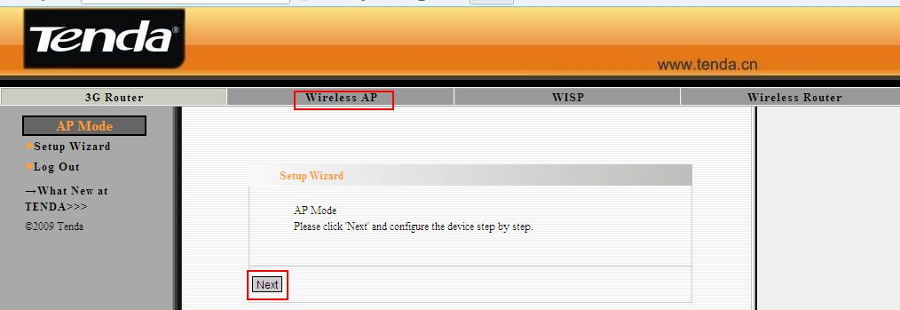
3, in this page, you can set the SSID (the name for your wireless network) and select a Channel; click Next.
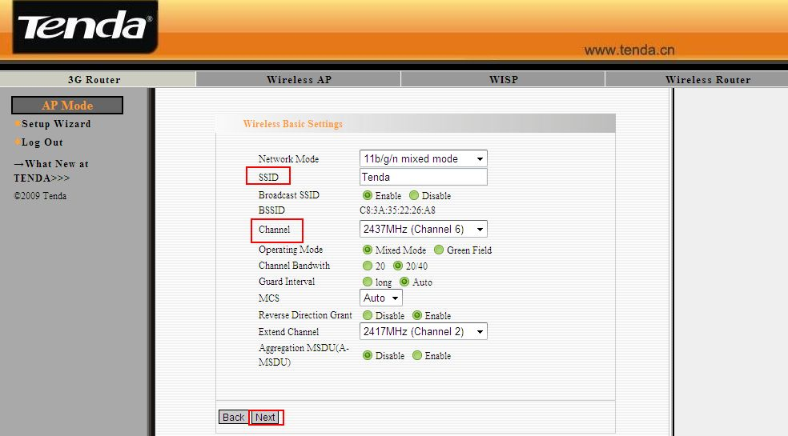
4. You are in the Wireless Security Settings page where you can set a password for your network. Please select WPA-Personal as the security mode and AES as the WPA Algorithms, then input at least 8 characters, numbers of letters, in the Pass Phrase. Click Next.
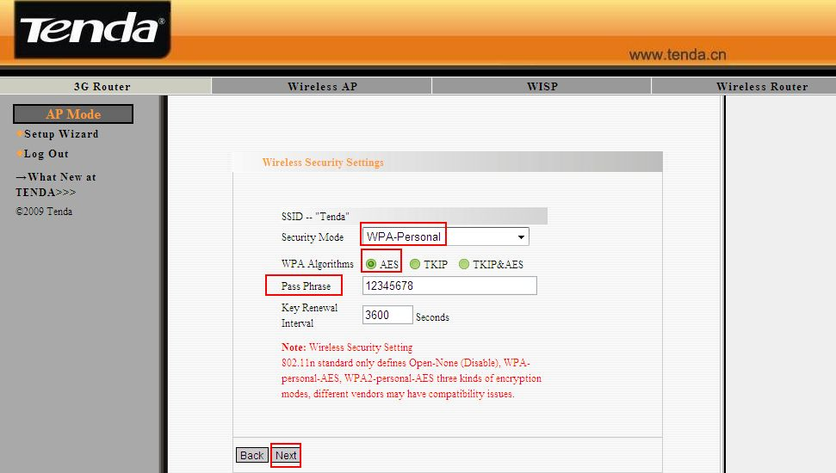
5. Click Apply and the router will reboot.
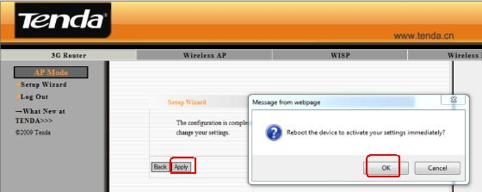
6. Then please connect the 3G150M as the topology, and your computers can connect to the wireless network of the 3G150M and will have the internet.

